Firmware upgrade

1. Before You Begin

VERY IMPORTANT: All the files and tools required for software updates/ drivers/ tools can be found under ftp.vonino.org.
As a first preventive measure, you can perform a HARD RESET before firmware upgrade. This allows you to save your personal files such as pictures or videos, but resets the device to its factory settings and uninstalls all the applications.
HARD RESET PROCEDURE:
The device must be turned off for this procedure. Simultaneously press the volume down and power key for aproximatively 10 seconds until the “Vonino” logo appears. The device will enter in the hard reset menu. Navigate through the menu using the volume keys and press the power key to select the desired “MMC” option in order to perform the hard reset.
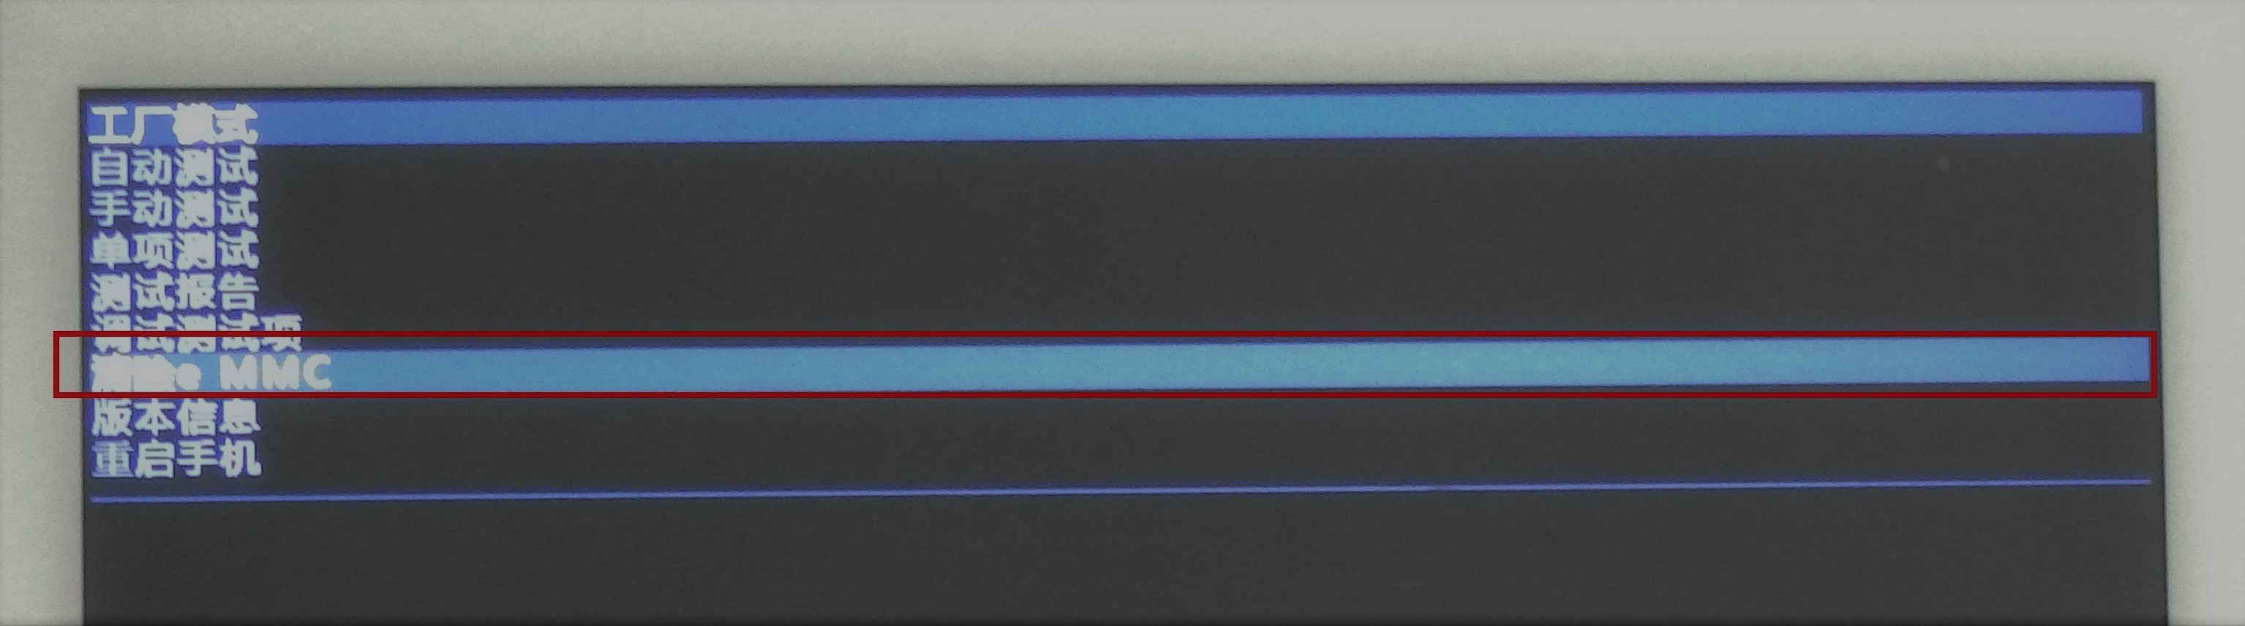

1.1. Computer and System Requirements

The computer must run Windows XP/Vista/Windows7 Operating System.

1.2. Data Cable

An USB Male to micro-USB Male cable is required.

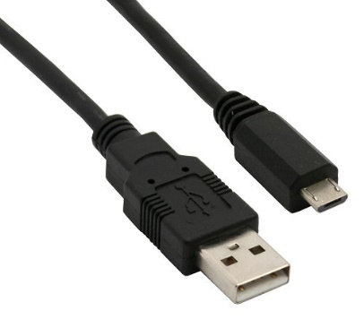

1.3. Cautions

- The device must be 30% charged.
- The software version of each faulty device should be upgraded to the latest one.
- The software version, download platform software and driver in this document are for reference only. Use the latest software to perform the software download.
- Be sure to back up all the user data form the device before starting the software download.
- The device will be out of use in the download process.

2. Install Driver

Prequisite:

- Please use the latest version of driver cable.
- Make sure the tablet has at least 30% battery and then turn it off.
- Connect the tablet to the PC(the tablet is turned OFF) via the required cable and proceed to install the drivers.
- Don’t disconnect the tablet during the process.

Access the drivers folder provided by the manufacturer and double click on the “Install” file.

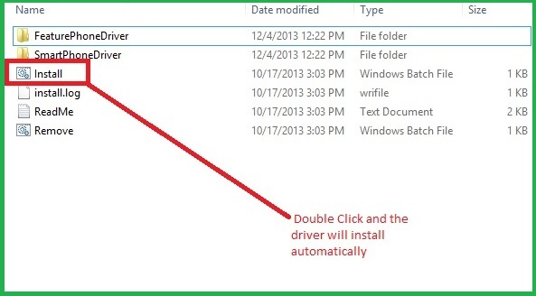

3. Download Software

Prequisite:

- Please use the latest version of driver cable.
- Make sure the device has at least 30% battery and then turn it off.
- Make sure the device is not connected to the PC.

Unarchive the Vonino Firmware compatible with your device. Open SP flash tool and click “OK” when the dialogue appears.

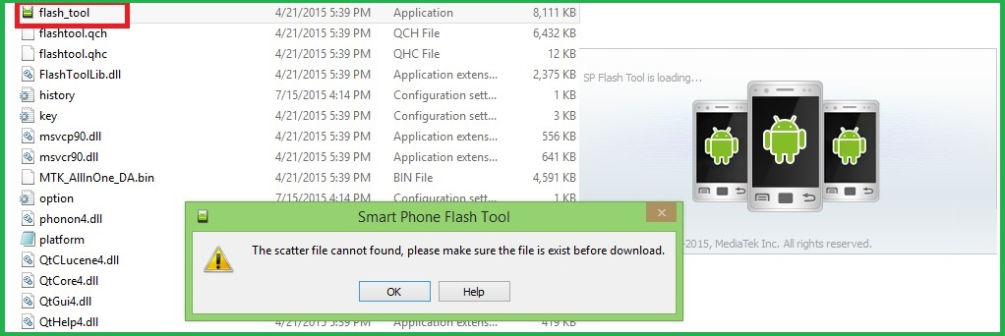

After SP flash tool opens, press the “Scatter-loading” button.

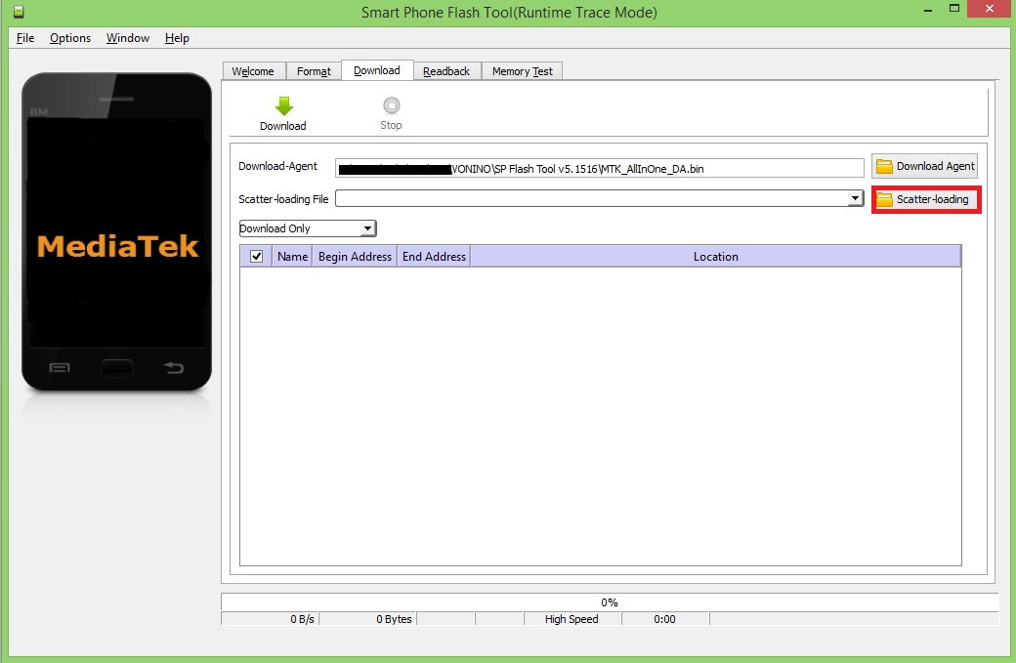

Load the Scatter file found in the Vonino SIRIUS QS folder by pressing “Open”.

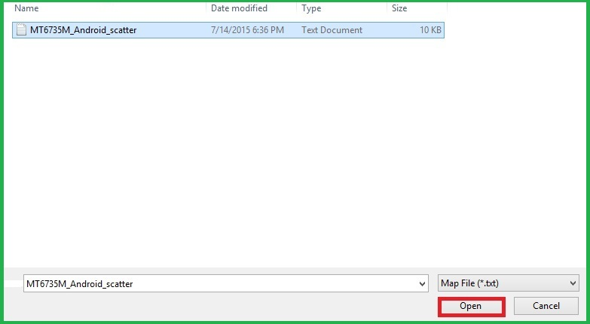

Press “Download” and the process shoud start.

NOTE: It is VERY IMPORTANT that after the download to connect the tablet to the PC.

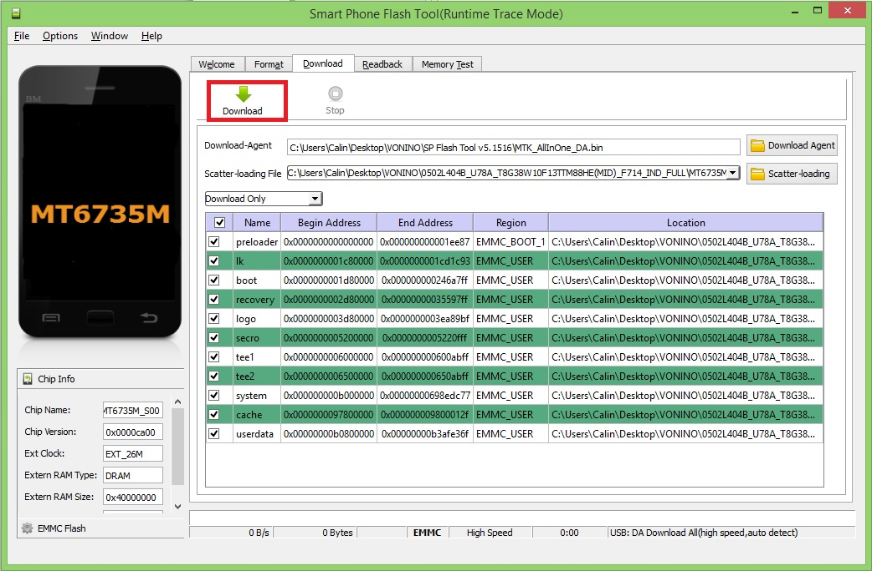

Finally, if the software download is successful, you should receive an “Download OK” message.

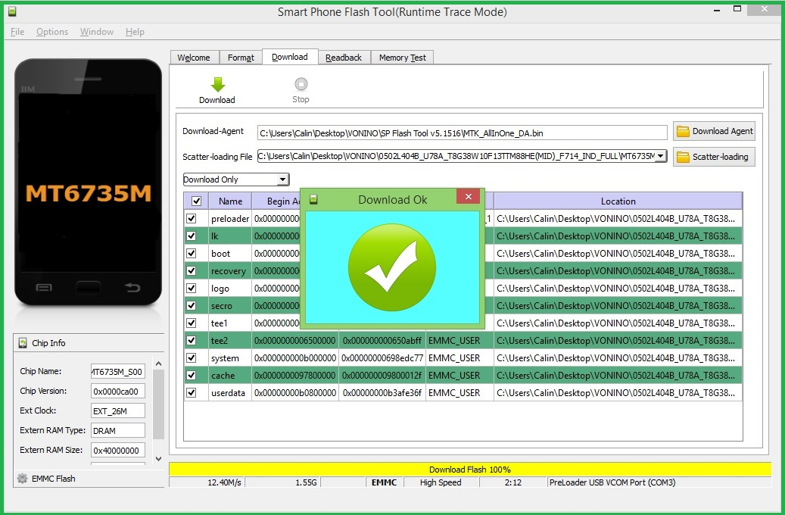

NOTE: If the software download fails make sure to RESTART the tablet (press and hold the power button for at least 10 seconds) and the process should be REDONE.

